Interview Preparation Questions

- What is the use of Security Groups in Active Directory?
- When accessing an application on a server, an error code 1053 is received. How would you troubleshoot this issue, and which logs would you check?
- Using the command line, how can you verify whether port 445 is in a listening state?
- What are the standard port numbers for DNS and SMTP?
- What is a CSR (Certificate Signing Request)? Explain how to export and import a certificate on a local machine.
- What is the difference between User DSN and System DSN in ODBC?
- What is an API?
- What are the different types of HTTP request methods?
- While browsing a webpage, an HTTP 503 error occurs. How would you troubleshoot this issue?
- Explain SAML architecture in detail.
- During SAML login, an "attribute mismatch" error occurs. How would you troubleshoot this issue?
- While migrating a server from on-premises to the cloud
- What pre-checks should be performed?
- If errors occur, where would you check the logs?
1 | What is the use of Security Groups in Active Directory?
2 | When accessing an application on a server, an error code 1053 is received. How would you troubleshoot this issue, and which logs would you check?
3 | Using the command line, how can you verify whether port 445 is in a listening state?
4 | What are the standard port numbers for DNS and SMTP?
5 | What is a CSR (Certificate Signing Request)? Explain how to export and import a certificate on a local machine.
6 | What is the difference between User DSN and System DSN in ODBC?
7 | What is an API?
8 | What are the different types of HTTP request methods?
9 | While browsing a webpage, an HTTP 503 error occurs. How would you troubleshoot this issue?
10 | Explain SAML architecture in detail.
11 | During SAML login, an "attribute mismatch" error occurs. How would you troubleshoot this issue?
12 | While migrating a server from on-premises to the cloud
 | What pre-checks should be performed?
 | If errors occur, where would you check the logs?

- What is the use of Security Groups in Active Directory?

Security Groups
Security Groups are collections of users, computers, or other groups that are used to assign permissions collectively instead of individually.

Instead of giving access to each user one by one, you
- Create a group
- Add users to that group
- Assign permissions to the group

Active Directory (AD)
Active Directory is a directory service developed by Microsoft used to
- Store information about users, computers, and resources
- Authenticate users (login process)
- Authorize access (who can access what)
- It acts like a centralized identity and access management system inside an organization.

Use of Security Groups in Active Directory
In Active Directory, Security Groups are mainly used for access control and permission management.

Key Uses:
- Access Management
- Grant access to shared folders, applications, printers, etc.
- Example: “HR_Group” can access HR files
- Simplified Administration
- Manage permissions at group level instead of user level
- Reduces manual work and errors
- Role-Based Access Control (RBAC)
- Users are grouped based on roles (Admin, HR, IT)
- Permissions assigned based on role
- Policy Application
- Security Groups can be used to apply Group Policies (GPOs)
- Scalability
- Easy to add/remove users without changing permissions again

Security Groups in Active Directory are used to organize users and assign permissions efficiently, enabling centralized and role-based access control to resources within an organization

- When accessing an application on a server, an error code 1053 is received. How would you troubleshoot this issue, and which logs would you check?

What is Error 1053?
Error 1053 means that a Windows service or application failed to respond to a start or control request within the expected time.

To troubleshoot, you should check system logs (Event Viewer), application-specific logs, and configuration settings such as service dependencies and timeout values.

Error 1053 - Simple Troubleshooting Steps
- Check the service status
Open Services (services.msc) and try to start the service manually if it hangs in "Starting"
- Review Event Viewer
Check Windows Logs → Application and System for related errors.
- Verify service dependencies
Ensure all dependent services are running.
- Check the service account
Verify the service account has the correct username/password and required permissions.
- Restart the server/service
Restart the service or reboot the server if needed.
- Check application/configuration files
Verify there are no incorrect configuration settings or missing files.
- Check resource usage
Ensure the server has sufficient CPU, memory, and disk space.
- Increase the service timeout (if required)
Modify the ServicesPipeTimeout registry value if the service needs more time to start.
- Reinstall or repair the application/service
If the service files are corrupted, repair or reinstall the application.

I will check the service status, restart it, analyze Event Viewer logs, verify dependencies and permissions, and check application logs to identify the issue.

- Using the command line, how can you verify whether port 445 is in a listening state?

What is CMD?
- CMD (Command Prompt) is a command-line interpreter in Windows.
- It lets you run commands directly to interact with the operating system, troubleshoot, and perform administrative tasks.
- Think of it as a text-based interface where you type instructions instead of clicking buttons.

What is Port 445?
- Port 445 is a TCP port used by Microsoft networking services.
- Specifically, it’s used for SMB (Server Message Block) protocol over TCP/IP.
- SMB allows file sharing, printer sharing, and communication between computers in a Windows network.
- Because it’s often targeted by malware, administrators sometimes check if it’s open or listening.

What is a "Listening" State?
- Think of a port like a specific door to a building (your computer).
- When a port is in a LISTENING state, it means a specific application or service has "opened" that door and is sitting right behind it, waiting for someone from the outside to knock.

How to verify port 445 in a listening stage using CMD

Step 1: Open Command Line
- Press Windows + R
- Type cmd
- Press Enter
- This opens the Command Prompt (command line tool)

Step 2: Run the command
- Type the below command and press Enter below command
netstat -an | find "445"

Step 3: Understand the output
- You will see something like below
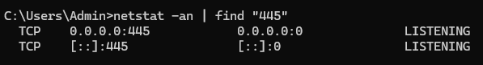
Step 4: Check “LISTENING”
- If you see LISTENING: ✅ Port 445 is active and waiting for connections
- If you don’t see anything: ❌ Port 445 is not listening

Using Command Prompt, run netstat -an | find "445".
If the output shows LISTENING, it means port 445 is active and accepting connections.

- What are the standard port numbers for DNS and SMTP?

4.1 Domain Name System (DNS)
- DNS (Domain Name System) translates human-readable domain names (like example.com) into machine-readable IP addresses.
- It is hierarchical and distributed, ensuring scalability and reliability across the internet.
- The standard port number used in DNS is 53

How DNS Works (Step-by-step)
- User enters a domain (e.g., google.com)
- You type google.com in your browser
- Your system needs the IP address to connect to the server
- Request goes to DNS Resolver
- Checks if it already has the IP in cache
- If yes: returns immediately (fast)
- If no: starts full DNS lookup process
- If not cached, it queries
- Root server: Entry point of DNS hierarchy.
- TLD server: Handle domain extensions (.com, .org, etc.).
- Authoritative name server: Store actual DNS records.
- Final IP address is returned
- Resolver gets the IP
- Stores it in cache for future use
- Browser connects to that IP
- Using the IP, browser sends request to web server
- Website loads

  - Simple Mail Transfer Protocol (SMTP)
- Simple Mail Transfer Protocol (SMTP) is the standard protocol used to send emails across the internet.
- SMTP is the "delivery truck" that moves mail from the sender's client to the recipient's server

How SMTP Works
The process functions as a series of handshakes between servers. When you hit "send," your email client acts as an SMTP Client, initiating a conversation with an SMTP Server.
- Email Submission: Your email client (like Outlook/Gmail) connects to SMTP server, it uses port 587
- Email Relay: Sender SMTP server checks receiver domain using DNS, send’s mail to recipient SMTP server and port number used os 25
- Receipt:
- The recipient’s mail server receives and stores the email
- The recipient later downloads it using IMAP or POP3, since SMTP only handles sending, not reading

Standard Port Numbers in SMTP
- DNS: Port 53 (UDP for queries, TCP for zone transfers).
- SMTP: Port 25 (mail transfer), 587 (secure email submission), and 465 (SMTP over SSL/TLS).

- What is a CSR (Certificate Signing Request)? Explain how to export and import a certificate on a local machine.

CSR stands for Certificate Signing Request, it refers to a message sent from an applicant (like a website owner) to a certificate authority (CA) to request a digital security certificate.

Purpose:
An SSL/TLS certificate establishes a secure connection between a web server and a client (web browser). A CSR is the first step in obtaining an SSL/TLS certificate. It contains information about the applicant's organization and public key, which will be used to create the certificate.

A CSR typically includes the following information:
- Common Name (CN): The domain name for which the certificate is being requested (e.g., "www.example.com").
- Organization Name (O): The legal name of the organization requesting the certificate.
- Locality (L): The city or town where the organization is located.
- State or Province Name (ST): The state or province where the organization is located.
- Country Name (C): The two-letter country code (e.g., "US" for United States).
- Public Key: The public key of the applicant's key pair. This key pair is used for encryption and decryption in the secure connection.

- What is the difference between User DSN and System DSN in ODBC?

  - What is ODBC
ODBC stands for Open Database Connectivity, it is a standard interface that allows applications to connect to different databases using a common method.

It acts as a bridge between an application and a database.
Example:
- Application: Excel, Power BI, SAP, Custom Application
- ODBC Driver: SQL Server Driver, Oracle Driver, MySQL Driver
- Database: SQL Server, Oracle, MySQL
Flow:
- Application → ODBC Driver → Database

  - What is DSN
DSN stands for Data Source Name, it is a saved ODBC connection configuration that contains details such as
- Database server name
- Database name
- ODBC driver
- Port number
- Authentication settings
Instead of entering these details every time, applications can use the DSN name to connect to the database.

  - Difference Between User DSN and System DSN

Feature | User (Data Source Name) DSN | System (Data Source Name) DSN
Availability | Only the user who created it | All users on the machine
Storage Location | User profile (Registry under current user) | System-wide Registry
Visibility | Visible only to that user | Visible to all users
Windows Services Access | No | Yes
Typical Use | Personal applications | Shared applications and services
Administrative Rights | Usually not required | May require administrator privileges

- What is an API?

API stands for Application Programming Interface is a set of rules and protocols that allows different software applications to communicate, exchange data, and share functionality.

Acting as an intermediary like a waiter in a restaurant it enables systems to interact securely without exposing internal code

How APIs Work (The Waiter Analogy)
- The Customer (Client): You want to order food from the menu.
- The Waiter (API): The messenger who takes your order (request) to the kitchen and brings your food (response) back to the table.
- The Kitchen (Server): The system that prepares your order. You don't need to know how the kitchen works to get your meal, you just need to know how to talk to the waiter

Types of API
- Public (Open) APIs: Available for any developer to use (e.g., Google Maps API).
- Private (Internal) APIs: Used only within a company to connect internal systems.
- Partner APIs: Shared only with specific business partners for collaboration.
- Composite APIs: Combine multiple data or service APIs into a single request to improve performance

Common Examples in Daily Life
- Weather Apps: Your phone app doesn't have its own weather satellites. It uses an API to "ask" a weather service like WeatherAPI for the current forecast.
- "Log in with Google/Facebook": Instead of creating a new account, a website uses an API to verify your identity through a service you already use.
- Travel Booking: Sites like Skyscanner use APIs to pull real-time flight prices from hundreds of different airlines instantly.
- Payments: When you buy something online, the store uses a Stripe or PayPal API to process your payment securely

- What are the different types of HTTP request methods?

HTTP - Hypertext Transfer Protocol
HTTP stands for Hypertext Transfer Protocol, and it’s the system that allows communication between web browsers (like Google Chrome or Firefox) and web servers.
- HTTP is a set of rules that lets your browser and web server communicate, ensuring websites load correctly.
- When you visit a website, your browser uses HTTP to send a request to the server hosting that site, and the server sends back the data needed to display the page.

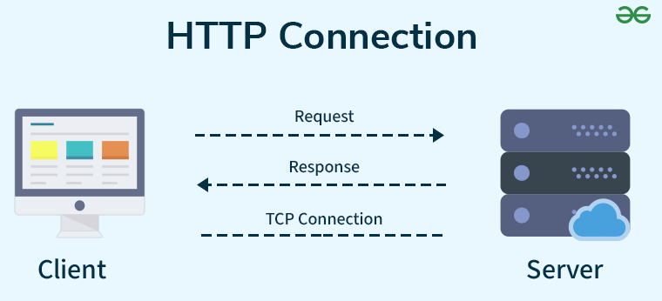

HTTP Port Number
- HTTP (HyperText Transfer Protocol) uses Port 80 by default.
- A port number is a logical communication endpoint used by applications and services to send and receive data over a network.
- When you open a website in a browser, the browser communicates with the web server using HTTP through Port 80.

How HTTP Works: Step-by-Step Process
Here’s how HTTP works when you visit a website:
- Open Web Browser: First, you open your web browser and type a website URL (e.g., www.example.com).
- DNS Lookup: Your browser asks a Domain Name System (DNS) server to find out the IP address associated with that URL. Think of this as looking up the phone number of the website.
- Send HTTP Request: Once the browser has the website’s IP address, it sends an HTTP request to the server. The request asks the server for the resources needed to display the page (like text, images, and videos).
- Server Response: The server processes your request and sends back an HTTP response. This response contains the requested resources (like HTML, CSS, JavaScript) needed to load the page.
- Rendering the Web Page: Your browser receives the data from the server and displays the webpage on your screen.

Different types of HTTP request methods
HTTP Requests are the message sent by the client to request data from the server or to perform some actions. Different HTTP requests are
- GET (Read data): Retrieves data from the server and returns status 200 on success.
- POST (Create new data): Sends data to create a resource and returns status 201 on success.
- PUT: Replaces the entire resource or creates it if not present.
- PATCH: Updates only specific parts of a resource.
- DELETE: Removes data from the server at a specified location.

- While browsing a webpage, an HTTP 503 error occurs. How would you troubleshoot this issue?

503 Error in HTTP
The HTTP 503: Service Unavailable error is one of the most common server-side issues
It means the server is reachable but temporarily unable to process the request

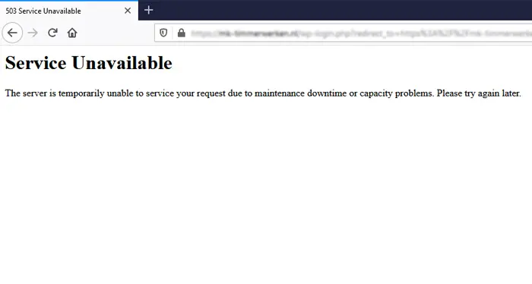

Most common reasons for 503 error
- Server overload: Too many concurrent requests exceed the server’s capacity.
- Maintenance mode: The site or application is intentionally offline for updates.
- Service down: Web server (IIS, Apache, Nginx) or application service has crashed or stopped.
- Database unavailable: Backend database server is down or unreachable.
- High resource usage: CPU or memory spikes prevent the server from handling requests.
- Load balancer issues: Misconfigured or unhealthy backend nodes in a cluster.
- Network/firewall problem: Connectivity blocked between client and server.
- Wrong configuration: Misconfigured app pools, connection limits, or server settings.

How to troubleshoot this issue?
- Verify service status: Ensures the web server and application services are running.
- Review logs: Web server, application, and system logs help pinpoint crashes, misconfigurations, or overload.
- Check resource utilization: Confirms whether CPU, memory, or disk bottlenecks are causing the issue.
- Verify backend connectivity: Ensures databases and APIs are online and responsive.
- Inspect load balancer: Confirms backend nodes are healthy and properly configured.
- Review recent changes: Identifies if new deployments or config updates introduced the error.

- Explain SAML architecture in detail.

SAML stands for Security Assertion Markup Language. It's an industry-standard protocol for authentication and authorization between entities in a web-based environment like Gmail, Facebook, Amazon, Flipkart, Service now, Sales force & AWS console
Imagine SAML as a secure way for different websites to exchange information about your identity, allowing you to log in once and access multiple applications without needing to re-enter credentials everywhere.

The Authentication Flow/ breakdown of how SAML authentication working

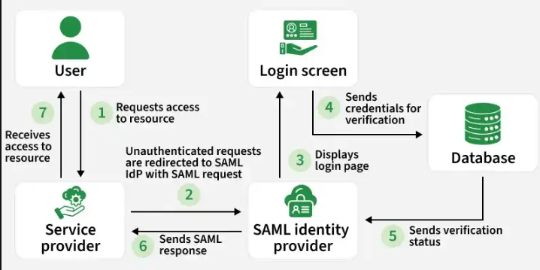

The Players involved are
- Identity Provider (IdP): This is a trusted service that holds user credentials and performs the initial user authentication. Often, this could be your company's login portal or a cloud-based identity provider service.
- Service Provider (SP): This is the website or application that you want to access using SAML authentication. Examples include web applications, cloud storage services, or corporate portals.
- User: You, the end-user trying to access the service provider's application.

The Authentication Flow
- User tries to access a Service Provider (SP): You attempt to access a web application that uses SAML authentication.
- Redirect to Identity Provider (IdP): The SP recognizes SAML and redirects you to the login page of your IdP. This is where you enter your username and password.
- User Authentication at IdP: The IdP authenticates you using your username and password. If successful, the IdP creates a SAML assertion containing information about your identity and access rights.
- SAML Assertion sent to SP: The IdP sends the SAML assertion back to the Service Provider. This assertion is a digitally signed token that securely confirms your identity and relevant access rights.
- User Access Granted (or Denied): The SP receives the SAML assertion, validates it with the IdP using digital signatures, and grants you access to the application based on the information in the assertion

- During SAML login, an "attribute mismatch" error occurs. How would you troubleshoot this issue?

🔎 What is an "Attribute Mismatch" Error in SAML?
During a SAML login, the Identity Provider (IdP) sends user information (attributes) to the Service Provider (SP). These attributes can include things like:
- Username
- Email address
- Group membership
- Role or department
An attribute mismatch error occurs when the attributes expected by the SP do not align with what the IdP is actually sending.

⚠️ Common Causes
- Attribute name mismatch: SP expects email Address, but IdP sends mail.
- Format mismatch: SP expects lowercase usernames, but IdP sends uppercase.
- Missing attributes: Required attribute (e.g., uid) not included in the assertion.
- Incorrect mapping: Admin misconfigured which IdP field maps to SP’s expected field.

🛠️ Troubleshooting Attribute Mismatch in SAML
- Capture Assertion: Use SAML tracer/logs to see what attributes the IdP is sending.
- Check Attribute Names: Make sure the names match what the Service Provider expects (e.g., email Address vs mail).
- Verify Attribute Values: Confirm formats (case sensitivity, domain suffix, etc.) are correct.
- Confirm Required Attributes: Ensure mandatory fields (username, email, groups) are present.
- Review Mapping: Check IdP configuration (Okta, Entra ID, ADFS) for proper field-to-attribute mapping.
- Check SP Settings: Validate that the SP is configured to accept the attributes being sent.
- Test with Known User: Try login with a test account to confirm the fix works

- While migrating a server from on-premises to the cloud
- What pre-checks should be performed?
- If errors occur, where would you check the logs?

Why do we migrating a server from on-premises to the cloud?
Organizations migrate servers from on-premises environments to the cloud to improve scalability, reduce infrastructure costs, and increase reliability. Cloud platforms also provide backup and disaster recovery capabilities, helping ensure business continuity.
- Cost Savings: No need to buy and maintain physical servers.
- Scalability: Easily increase or decrease resources.
- High Availability: Better uptime and reliability.
- Security: Built-in security and monitoring features.
- Easy Management: Less effort for maintenance and updates.
- Backup & Disaster Recovery: Faster recovery during failures.

Step by step process of migrating a server from on-premises to the cloud

- Assessment & Preparation
Understand your current environment and define migration goals.
- Identify stakeholders and assign a project manager
- Document applications, workloads, and dependencies
- Assess compliance, regulatory, and security requirements
- Perform resource utilization analysis (CPU, memory, storage, network)

- Planning & Strategy
Choose the right migration approach and create a roadmap.
- Select migration strategy: Rehost (lift‑and‑shift), Refactor, Replatform, or Replace
- Prioritize workloads based on complexity and business impact
- Define timelines, budget, and risk mitigation plans
- Establish rollback and disaster recovery strategies

- Pre‑Migration Checks (Critical Step)
- Validate readiness before moving workloads.
- Perform full backups and test restores
- Map dependencies to avoid broken connections
- Validate network configuration (firewall rules, DNS, IP addressing)
- Ensure IAM roles and encryption policies are in place

- Migration Execution
- Move workloads to the cloud using migration tools.
- Use cloud migration services (e.g., AWS Application Migration Service, Azure Migrate)
- Transfer data in waves or sprints to minimize downtime
- Monitor logs during migration for errors
- Validate application functionality after each wave

- Testing & Validation
- Ensure workloads perform correctly in the cloud.
- Conduct smoke tests and user acceptance testing
- Compare performance against baseline metrics
- Validate compliance and security controls
- Check application, database, and system logs for anomalies

- Optimization & Cutover (Final Step)
- Finalize migration and optimize cloud resources.
- Switch production traffic to cloud workloads
- Decommission or repurpose on‑premises servers
- Optimize cloud resources for cost and performance
- Implement monitoring and alerting with CloudWatch, Azure Monitor, or GCP tools

What pre-checks should be performed?
- Check server specifications: CPU, RAM, Storage, OS.
- Verify compatibility: Applications and OS versions supported in the cloud.
- Review network settings: Firewall rules, DNS, and dependencies.
- Validate backups: Take and test backups of data and applications.
- Assess security: IAM roles, encryption, compliance requirements.
- Estimate cloud resources: Right‑size CPU, memory, and storage in the cloud.
- Plan downtime & rollback: Schedule migration windows and prepare a fallback plan.

If errors occur, where would you check the logs?
- Application logs: Identify application‑specific issues (e.g., IIS, Apache, Nginx, or custom app logs).
- Operating System logs: Windows Event Viewer (System/Application) or Linux /var/log/messages, /var/log/syslog.
- Migration tool logs: Errors reported by migration utilities like AWS Migration Hub or Azure Migrate.
- Cloud service logs: AWS CloudWatch, Azure Monitor, GCP Stackdriver for resource utilization and error traces.
- Network and firewall logs: Firewall logs, VPC flow logs, packet captures for connectivity issues.
- Database logs: SQL Server, MySQL, PostgreSQL logs for query failures or connection drops.

